

Turtlebot-Laptop Power Cable Assembly Instructions
Includes:  -Power Cable  -2 Connector Pins  -Heat Shrink  -Molex 6 Pos Connector | 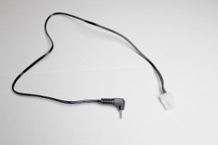

Step 1) Cut Laptop Power Supply to a length of 2'.

Step 2) Strip the ends of the wires to .35”.

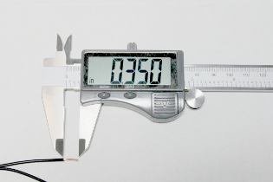

Step 3) Cut approximately 1.5” of heat shrink and put it over the cut wire, DO NOT HEAT YET.
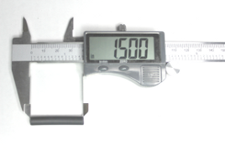

Step 4) Insert the wires into the connector pins. Make sure the wire casing stops within the central channel. Next, crimp the clips around the exposed copper wire and the center clips. Do not crimp the 3rd clip pair.
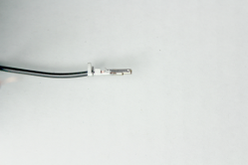

Step 5) Insert the ground pin into the middle hole next to the clip on your Molex connector, make sure “up” on the pin is aligned with the plastic clip. You can use a screwdriver to push it in until it clicks.

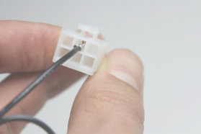

Step 6) Insert VCC pin directly below the ground pin.
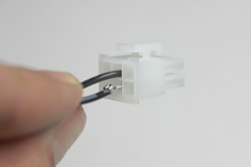

Step 7) Bring heat shrink up to the Molex connector and apply even heat.

CONGRATULATIONS!!!! You have completed your Turtlebot to Laptop Power Cable!!!!

